BEFORE STARTING ENGINE
Preflight Inspection COMPLETE
Passenger Briefing COMPLETE
Seats, Belts, Shoulder Harness ADJUST & LOCK
Fuel Selector Valve PROPER TANK (lowest)
Autopilot OFF
Electrical Equipment/Avionics OFF
Brakes SET
Circuit Breakers CHECK IN

STARTING ENGINE
Avionics/Radio Master OFF
Mixture RICH
Carburetor Heat COLD (IN)
Prime AS REQUIRED (2-6)
Throttle OPEN 1/8”
Master Switch ON
Fuel Pump ON and CHECK pressure
Propeller Area CLEAR
Ignition Switch START
Oil Pressure CHECK
Throttle WARM UP @ 1000RPM
Fuel Pump OFF
Mixture Lean for Smooth Running
Avionics/Radio Master ON

BEFORE TAXI
Lights & Flashing Beacon AS REQUIRED
Audio Panel SET
DG SET
Flaps UP
Weather Information OBTAIN
Brakes TEST

BEFORE TAKEOFF
Parking Brake SET
Doors and Windows CLOSE & LOCK
Flight Controls FREE & CORRECT
Fuel Selector Valve PROPER TANK (fullest)
Fuel Quantity CHECK
Oil Temp CHECK
Mixture RICH
Throttle 2000 RPM
Magnetos CHECK (125 max +- 50 difference)
Carburetor Heat CHECK for RPM Drop
Engine Instruments & Ammeter CHECK
Suction Gage CHECK
Throttle IDLE then 1000 RPM
Throttle Friction Lock ADJUST
Elevator and Nose Trim SET for T/O
Fuel Pump ON
Flight Instruments CHECK & SET
Radios SET
Transponder ALTITUDE
Lights AS DESIRED
Brakes RELEASE

TAKEOFF

NORMAL
Wing Flaps UP
Carburetor Heat COLD (IN)
Elevator Trim SET
Mixture MAX RPM (RICH)
Throttle FULL OPEN
Elevator Control LIFT NOSE WHEEL (55 MPH)
Climb Speed 85 MPH

SHORT FIELD TAKEOFF
Wing Flaps ………..Short field 0..……...Soft field 25
Carburetor Heat COLD (IN)
Elevator Trim SET
Brakes APPLY
Mixture MAX RPM (RICH)
Throttle FULL OPEN
Brakes RELEASE
Elevator Control SLIGHTLY TAIL LOW
Climb Speed 74 MPH

ENROUTE CLIMB
Airspeed 100 MPH
Throttle FULL OPEN
Mixture RICH
Fuel Pump ON

CRUISE
Power 2200 – 2500 RPM
Elevator Trim ADJUST
Mixture LEAN
Fuel Pump OFF

DESCENT
Fuel Selector Valve PROPER TANK (fullest)
Power AS DESIRED
Mixture ADJUST

BEFORE LANDING
Seats, Belts, Harnesses SECURE
Autopilot OFF
Fuel Selector Valve PROPER TANK (fullest)
Fuel Pump ON
Mixture RICH
Carburetor Heat AS REQUIRED

LANDING
NORMAL LANDING
Wing Flaps AS DESIRED (below 115 MPH)
Airspeed 80 – 85 MPH (flaps down)
Touchdown MAINS FIRST
Landing Roll LOWER NOSEWHEEL GENTELY
Braking MINIMUM REQUIRED

SHORT FIELD LANDING
Wing Flaps FULL DOWN
Airspeed 80 MPH (until flare)
Throttle REDUCE to Idle after clearing obstacle
Touchdown MAINS FIRST
Landing Roll LOWER NOSEWHEEL GENTELY
Braking AS REQUIRED

GO-AROUND
Throttle FULL OPEN
Carburetor Heat COLD (IN)
Wing Flaps RETRACT SLOWLY
Climb Speed 74-85 MPH

AFTER LANDING
Carburetor Heat COLD (IN)
Wing Flaps UP
Mixture ……………………………………………Lean
Fuel Pump OFF
Lights As Required

SHUTDOWN
Brakes SET
Avionics Master OFF
Electrical Equipment & Lights OFF
Mixture IDLE CUTOFF
Master OFF
Ignition Switch OFF
Control Lock INSTALL
Hobbs RECORD
Aircraft SECURE
Flight Plan CLOSE

ENGINE FAILURE DURING TAKEOFF RUN
Throttle IDLE
Brakes APPLY
WITH FIRE
Mixture IDLE CUT-OFF
Ignition Switch OFF
Master Switch OFF

ENGINE FAILURE IMMEDIATELY AFTER TAKEOFF
Airspeed 80 MPH (flaps up) 70 MPH (flaps down)
Mixture IDLE CUT-OFF
Fuel Selector Valve OFF
Ignition Switch OFF
Wing Flaps As Required
Master Switch OFF

ENGINE FAILURE DURING FLIGHT
Airspeed 80 MPH
Carb Heat ON
Fuel Selector Valve SWITCH TANKS
Fuel Pump ON
Mixture RICH
Ignition Switch BOTH (or Start if prop stopped)
Primer IN & LOCKED
Transponder 7700
Radio 121.5 MAYDAY!

EMERGENCY LANDING W/O POWER
Airspeed 80 MPH (flaps up) 70 MPH (flaps down)
Mixture CUT-OFF
Fuel Selector Valve OFF
Ignition Switch OFF
Wing Flaps As required (full recommended)
Master Switch OFF
Door UNLATCH PRIOR TO TOUCHDOWN
Touchdown Slightly Tail Low (min. speed)
Brakes APPLY HEAVILY

Max Weight 2400 lbs Useful Load 972.5 lbs
Useful Load Full Fuel 678.5 lbs Max Baggage 200 lbs
Oil Capacity 8 qts Fuel Capacity 50 gal Usable Fuel 49

Vso 57 MPH Vfe 115 MPH Downwind 90
Vs1 67 MPH Va 129 MPH Base 85
Vx 74 MPH Vno 140 MPH Final 80
Glide 80 MPH Vne 171 MPH Short 76
Vy 85 MPH X-wind 15 kts TAS 143

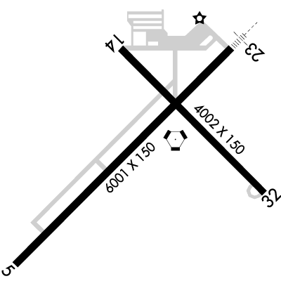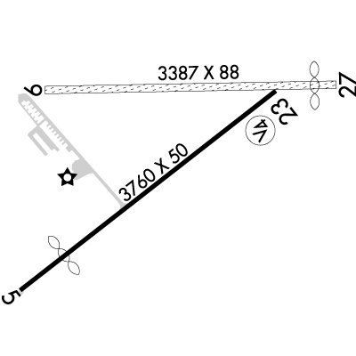

Glenndale (8I3)
CTAF 122.90

Grissom (KGUS)
APPROACH 121.05(East) 123.85(West)
TOWER 133.7
GROUND 128.425
ATIS 108.45
CLEARANCE 120.0

Indy Exec (KTYQ)
CTAF 123.05
AWOS 120.725
(317-796-3154)

Kokomo (KOKK)
CTAF 123.0
AWOS 128.675
(765-452-3014)

Logansport (KGGP)
CTAF 122.8
AWOS 118.5
(574-737-7310)

Marion (KMZZ)
CTAF 122.7
AWOS 108.6
(765-674-1317)

Muncie (KMIE)
TOWER (CTAF) 120.1
GROUND 121.9
ATIS 133.25
UNICOM 122.95

Noblesville (I80)
CTAF 122.9

Sheridan (5I4)
CTAF 123.075

Westfield (I72)
CTAF 122.90

